

Designing with Canva

How to Use Canva
A User-Based Documentation Guide

Prepared by:
Ashley Brein for Code for Nepal

Attribution-NonCommercial-ShareAlike

CC BY-NC-SA



Table of Contents

PAGE 1: Title Page

PAGE 2: Table of Contents

PAGE 3: List of Figures

PAGE 4: Definitions

PAGE 5: Introduction

PAGE 6-7: Designing Basics (Steps 1-4)

PAGE 8: Growing Your Skills (Steps 5 and 6)

PAGE 9: Completing Your Design (Steps 7 and 8)

PAGE 10: Additional Tips

PAGE 11-12: Design Inspiration



List of Figures

Figure 1: Navigating to Canva website Figure 8: Adding Text Elements

Figure 2: Creating a Canva Account Figure 9: Adjusting Text Elements

Figure 3: Choosing a Design Figure 10: Text Enlargement

Figure 4: Instagram Post Option Figure 11: Adding Music or Videos

Figure 5: Choosing A Template Figure 12: Saving Your Design

Figure 6: Uploading Images & Videos Figure 13: Sample Poster

Figure 7: Browsing Canva Gallery Figure 14: Sample Social Media Post

Figure 15: Sample Business Logo


GETTING STARTED WITH CANVA

Definitions

“Button” - a control that allows you to confirm an action or trigger an event you wish to take place on a computer


“Icon” - a picture that helps you navigate a computer system or website


“Template” - pre-made designs that come with their own fonts/color schemes to use. Some-times, these make the process of designing a lot easier.


“Highlight” - the emphasis on a button, element, icon, etc. to draw attention to it

“Element” - different visual features that can be added to enhance a design
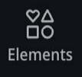

“Upload/Download” - the act of moving files and other documents to and from a computer, device, or website
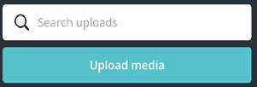

 |  |  |  | CLIENT NAME | 4


GETTING STARTED WITH CANVA

Introduction

What is Canva?

Canva is a free, online design platform available on the Internet. It lets you create, develop, and design items for social, print, and broadcast media. This can include event flyers, classroom presentations, social media posts, and other forms of design.

Canva is attractive to many individuals because it’s free and can be easily accessible. Canva is also versatile -- available for both personal use and for professional work in many career fields (marketing, advertising, com-munications, education, etc.) You are also able to collaborate with others on projects.

With hundreds of free templates, icons, images, photo filters, and fonts, users have access to whatever they may need throughout their creative process.

Why Should You Use Canva?

Canva offers you an easy way to communicate visually appealing messages to a variety of audiences. You have the opportunity to use it for social me-dia graphics, presentations for teaching in the classroom, and much more.

By learning, exploring, and discovering Canva, you are:

- Growing your skills in design and content development

- Enhancing your creative identity and self-expression

- Building knowledge on how to proficiently use innovative software

- Expanding your exposure to the digital landscape

- Becoming a more competitive and valuable applicant to employers

- Increasing job opportunities

 |  |  |  | CLIENT NAME | 5

DESIGNING BASICS

STEP 1: Create Your Account

Navigate to the Canva website by searching www.canva.com in your web browser. (Figure 1)

- Click on the “Sign Up” button on the top right of your screen, highlighted in red (Fig-ure 2).

- Answer the informational questions to set up your personal account (you may sign up using other media accounts like Facebook, Google, or email).

STEP 2: Choose A Graphic

Once you have created your account, you are able to begin editing your first design.

- Click on the blue “Create A Design” button in the top right of your screen (Figure 3).
- Click on “Instagram Post” below the search bar (Figure 4). There are many options to choose from, so we will start with a basic design advertisement for now.

Figure 1
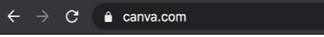
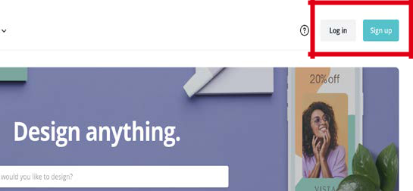

Figure 2
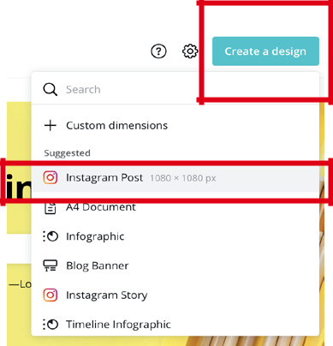

Figure

3

Figure

4

CLIENT NAME | 6

STEP 3: Use a Template

The left side of the screen has all of Canva’s editing options, with the first option being “Templates” (Figure 5).

- You may choose one of these to gain some inspiration and assist you in your design process.

STEP 4: Upload Images and Videos

The next icon is “Uploads”, which moves pho-tos and videos from your device to your de-sign. There are also photos available to you in the next icon down that says “Photos”.

- Select the blue button that says “Upload an image or video” (Figure 6).
- It will then prompt you to choose where you would like to upload the photo or vid-eo from.

- Explore the photos that Canva offers (Fig-ure 7).

DESIGNING BASICS
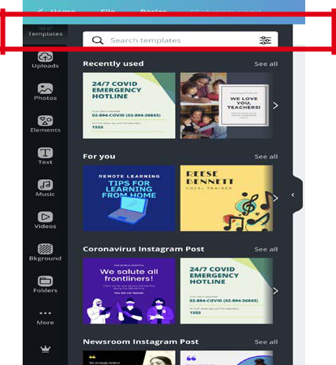

Figure 5
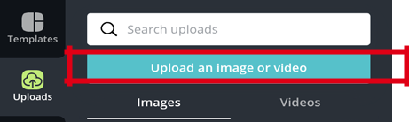

Figure 6
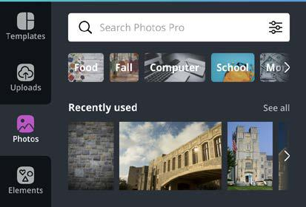

Figure 7

CLIENT NAME | 7

GROWING YOUR SKILLS
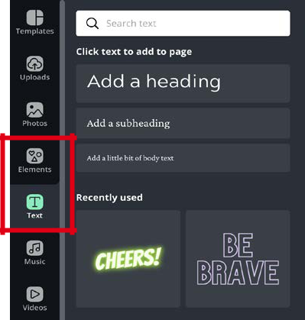

STEP 5: Add Text and Other Elements

Click on the “Text” and/or “Elements” icons on the left to explore what kinds of headings and fonts can be added. (Figure 8)

- Once the text is added to the page, double click on the letters of the text to type what you would like to say.

Figure 8

STEP 6: Adjust Text and Other Elements on the Page

To adjust a text, shape, or photo, click on the element you would like to alter. A blue box will surround the element. (Figure 9)

- Click and drag on the white circle, located in the cor-ners of the blue rectangle, to adjust the size. (Figure 10)

- Click and drag anywhere on an element to reposition it around the page.

Figure 9
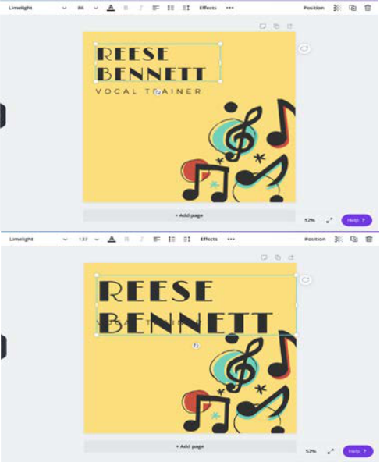

Figure 10

CLIENT NAME | 8

COMPLETING YOUR DESIGN
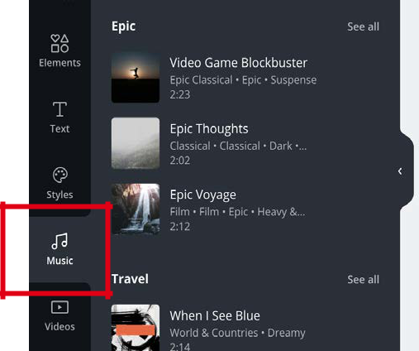

STEP 7: Add Music, Video, and Background

The last thing you may do is add music or video to your design.

- Click on the “Music” or “Video” icons on the left side of your screen. (Figure 11)
- Scroll through the audio/video clip options and click on the one you would like to apply to your page.

Figure 11

STEP 8: Save and Print Your Design
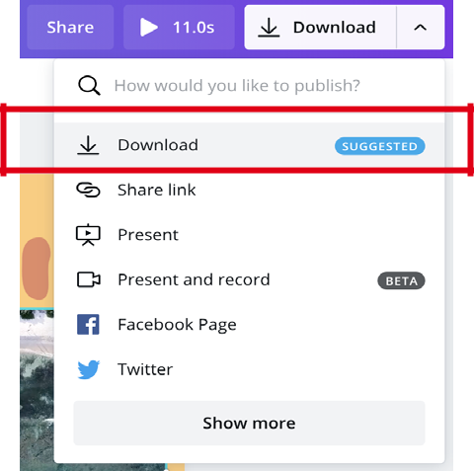

Once your design is finished, you are ready to download or print. Remember, Canva automatically saves changes as you work on your design.

- To share your design with another person, click the “Share” button in the top right of your screen.
- To download, click the “Download” button and choose the format you would like to download your design in. (Figure 12)

Figure 12

CLIENT NAME | 9

ADDITIONAL TIPS

Experiment with other design elements.

Other formats are available on Canva, such as posters, business cards, t-shirts, brochures, flyers, and more. There are even ways to design with your favorite social media like Twitter, Pinterest, LinkedIn, etc. Don’t be afraid to try out the options!

Name your design project.

Start by moving your cursor over the “Untitled Design” box in the top right, next to “Share”.

- Click on it and begin typing the new title of your design. This way, you can stay organized and keep track of your projects as they automatically save.

Manage your designs.

As you create more design projects, you can keep track of them all by organizing them into folders. Folders are used to section off your dif-ferent designs, allowing you to group similar ones together.
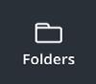
- Access your folders by clicking on the “Folder” icon.

Copy and delete elements of your design by selecting them.

- Once selected, use the trashcan icon in the top right to delete the element, or the duplicate icon to duplicate the element. These two icons are located right next to each other.

- Add and delete pages to your design by hovering the cursor over the 3 icons in the top corner of your page to use each button.
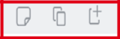

Canva has so much to offer.

Learn more by exercising your skills and trying new buttons and formats. Enhance your understanding of Canva and grow your digital literacy at your own pace!

CLIENT NAME | 10



Know the
COVID-19

SYMPTOMS

The following symptoms may appear 2-14 days after exposure:

Fever

Cough

Shortness of Breath

Seek medical advice if:

You develop worsening symptoms

You have been in close contact with a person known to have COVID-19 You live in or have recently been

in an on area with ongoing

spread of COVID-19

FOR MORE INFORMATION, VISIT CDC.GOV

Figure 13:
Poster sharing informa-tion about COVID-19 and potential symptoms.

INSPIRATION

SAMPLE

DESIGNS


Figure 14:
Social Media post for new
fashion line, Jade Claire,
coming soon.


Figure 15:
Business logo for Ayurve-
da, a natural makeup
brand.

CLIENT NAME | 11

INPSIRATION

Learn, Explore,

Discover

“You can’t use up creativity. The more you use

the more you have.”

-- Maya Angelou

www.canva.com
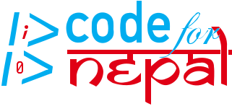

CLIENT NAME | 12

